Task: Sales Data Integration & Modeling
Objective
Integrate multiple CSV files, clean and transform data using Power Query, and validate results through analytical questions.

Business Scenario
You are a Business Intelligence Analyst working for a retail company that sells products across multiple categories and regions. Sales data is available for multiple years but stored in separate CSV files. Your task is to integrate, clean, and structure the data so it can be used for reporting and dashboards.

CSV FILES TO BE USED - You can check in the Resource section
powerbi_Resource_Data
Fact Tables
Company Sales Data 2020.csv
Company Sales Data 2021.csv
Company Sales Data 2022.csv
Lookup Tables
- Company Product Lookup.csv
- Company Product Subcategories Lookup.csv
- Company Product Categories Lookup.csv
- Company Calendar Lookup.csv

Part 1: Sales Data Consolidation
Tasks
- Load all three sales CSV files into Power BI.
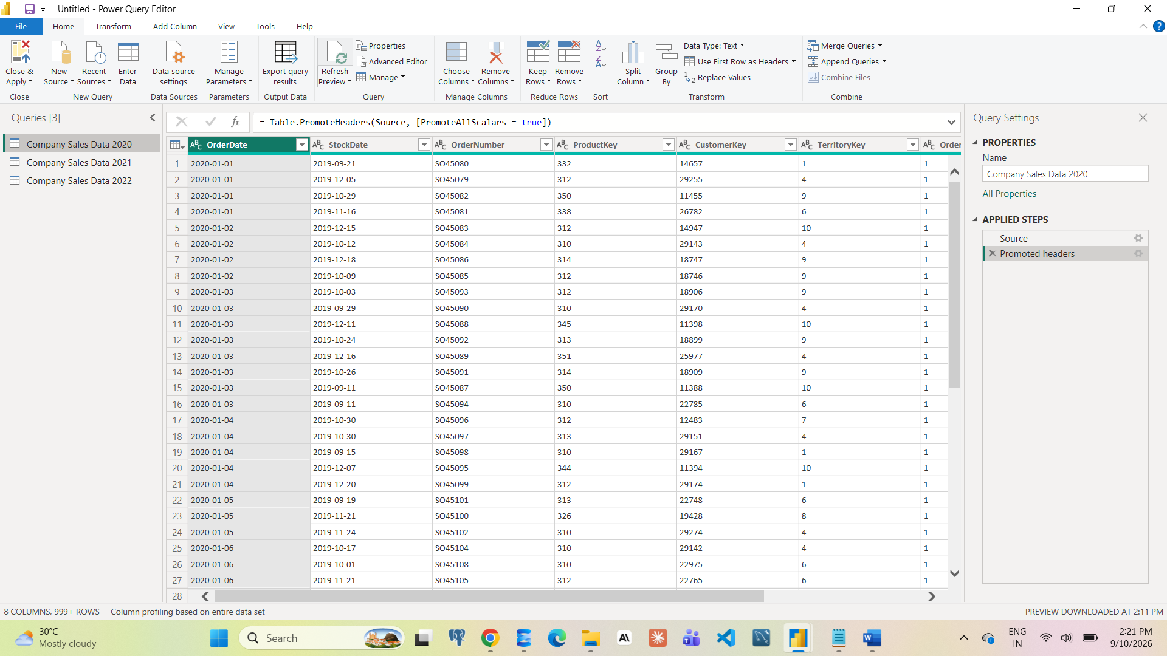
- Append them into one single table.
Power Query Editor – Home – Append Queries – Append Queries as New
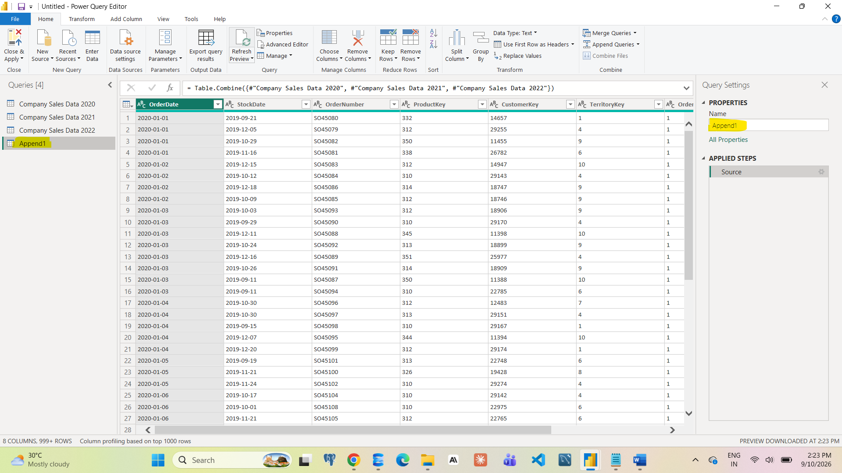
- Rename the final query as Fact_Sales.
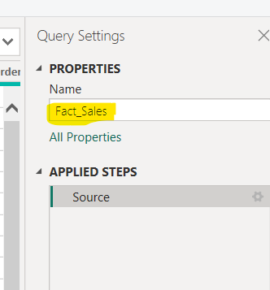
- Verify correct data types:
OrderDate → Date
StockDate → Date
OrderQuantity → Whole Number
Changed data type as per columns
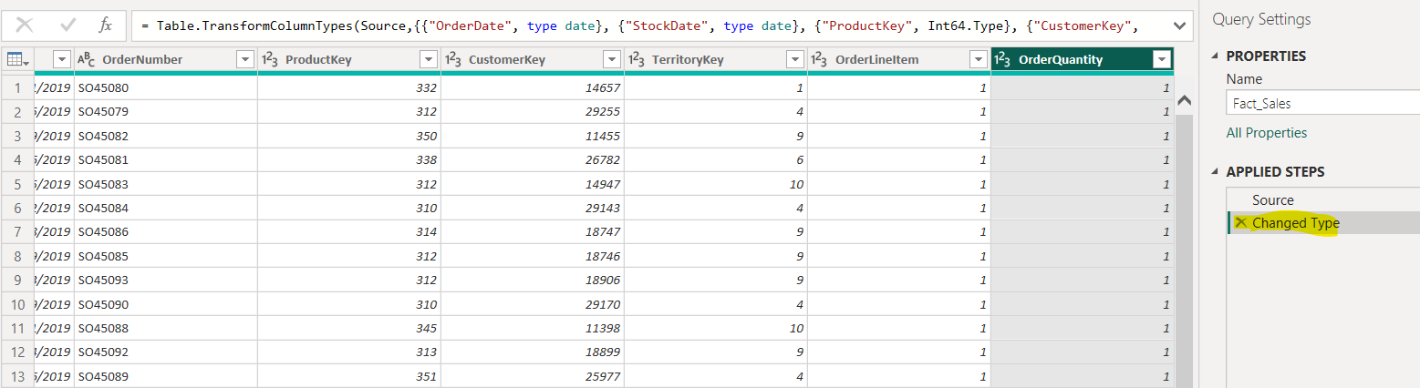

- Create the following columns using Power Query:
Year (from OrderDate)
Month Name (from OrderDate)
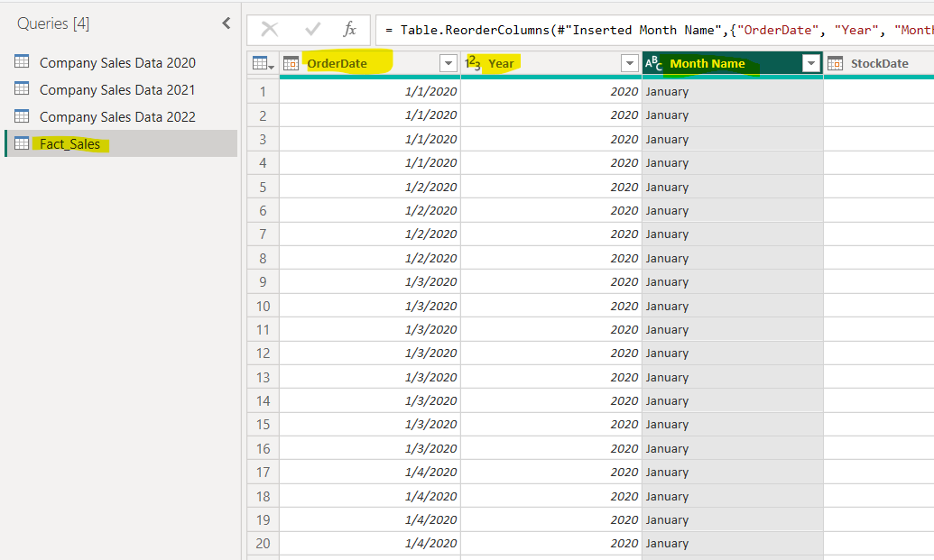

- Add an Index Column starting from 1.
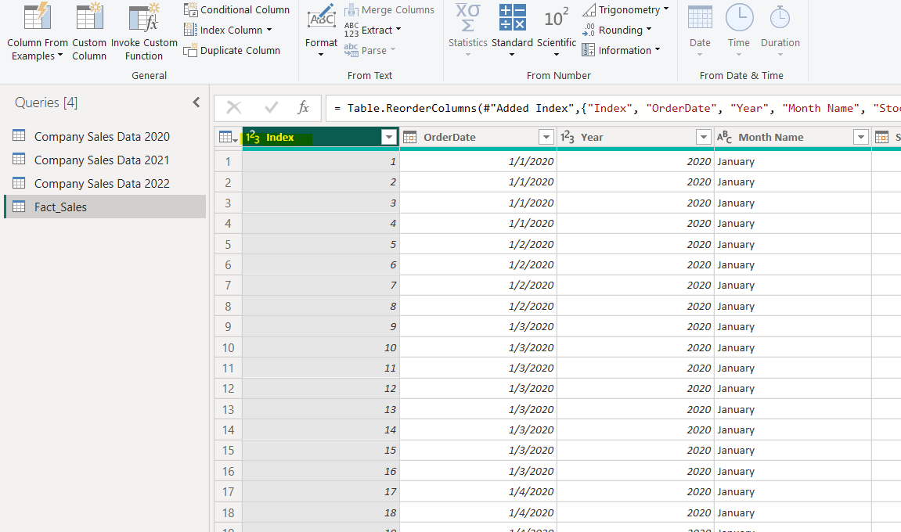
Submission Type : Screenshot of this part is required and saved in Doc/PDF file.
Analytical Questions
Q1. Calculate Year-wise total OrderQuantity and identify the year with the highest quantity sold.
Q2. Identify the top 3 months by total OrderQuantity (use Month Name).
Q3. Count number of records per year after appending.
Submission Type : Answer of this part is required and saved in Doc/PDF file.
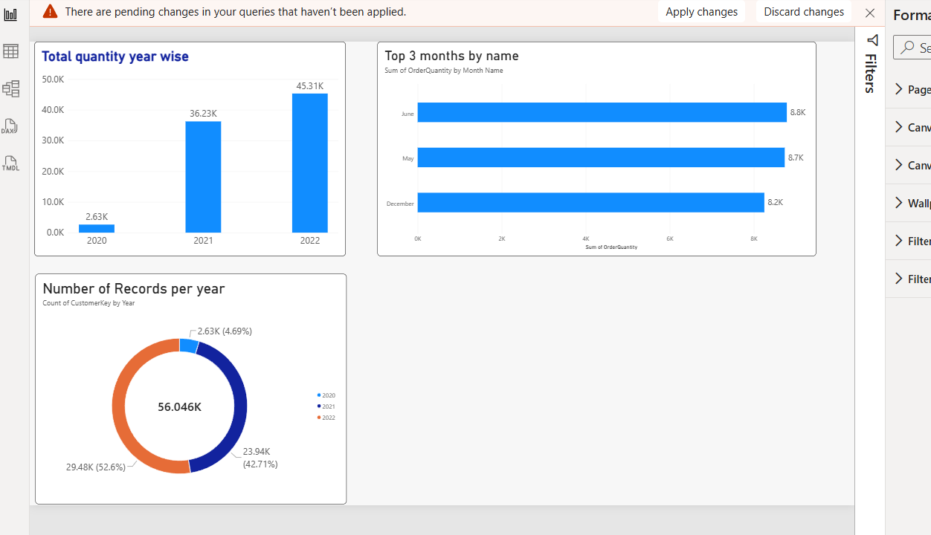
Part 2: Product Hierarchy Creation
Tasks
- Merge Product Lookup with Product Subcategories.
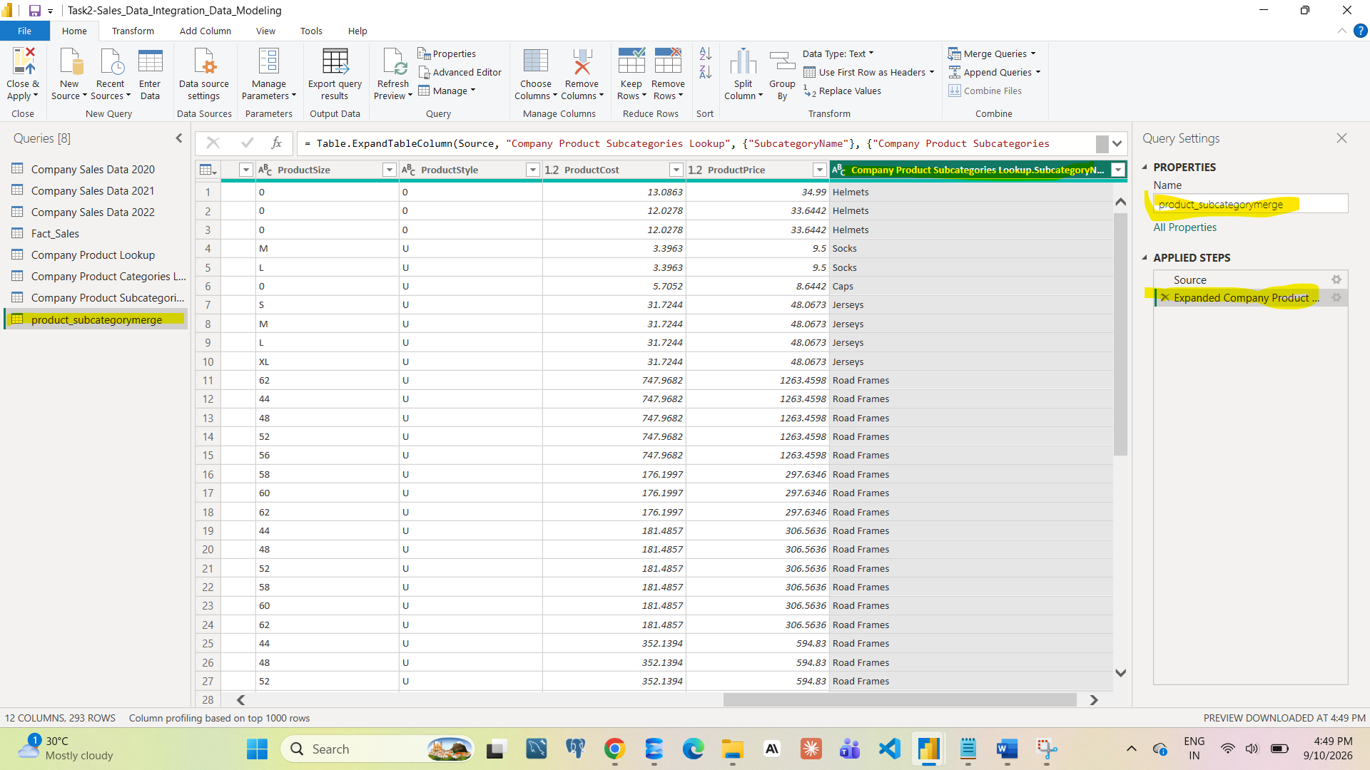
- Merge the result with Product Categories.
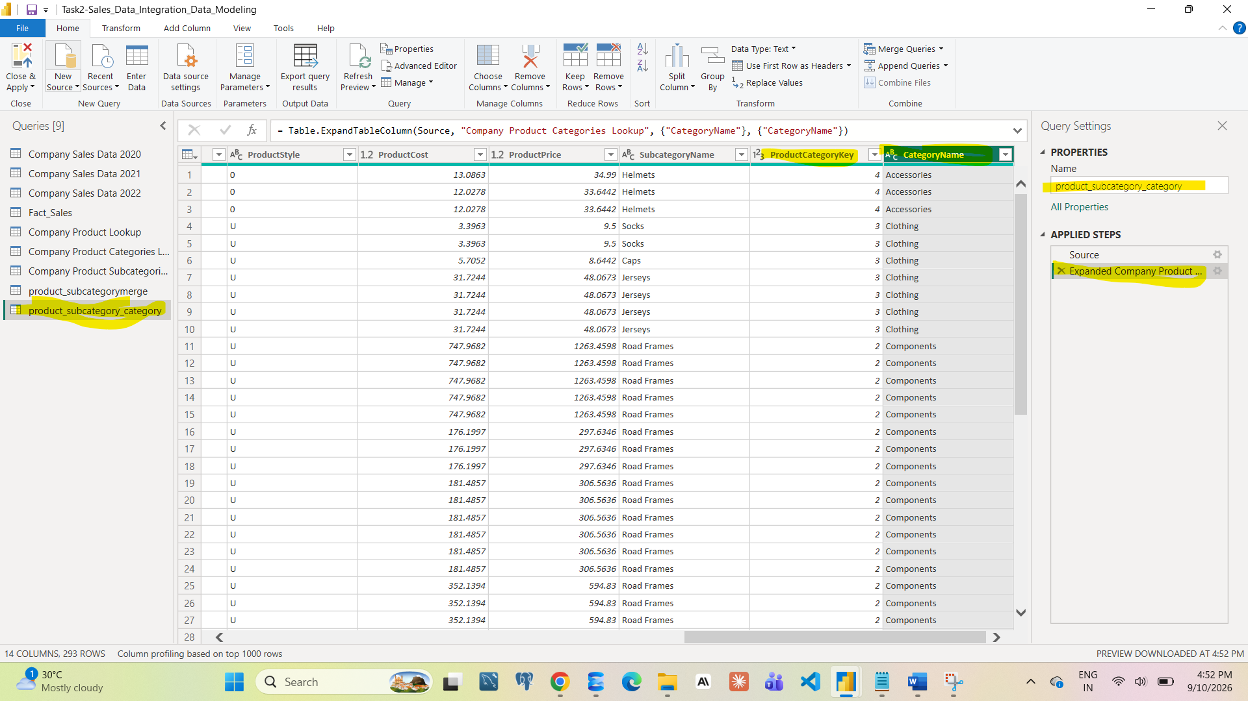
- Validate ProductKey uniqueness.
- Create a numeric column:
  - Profit Margin = ProductPrice − ProductCost
- Rename the final query as Dim_Product.
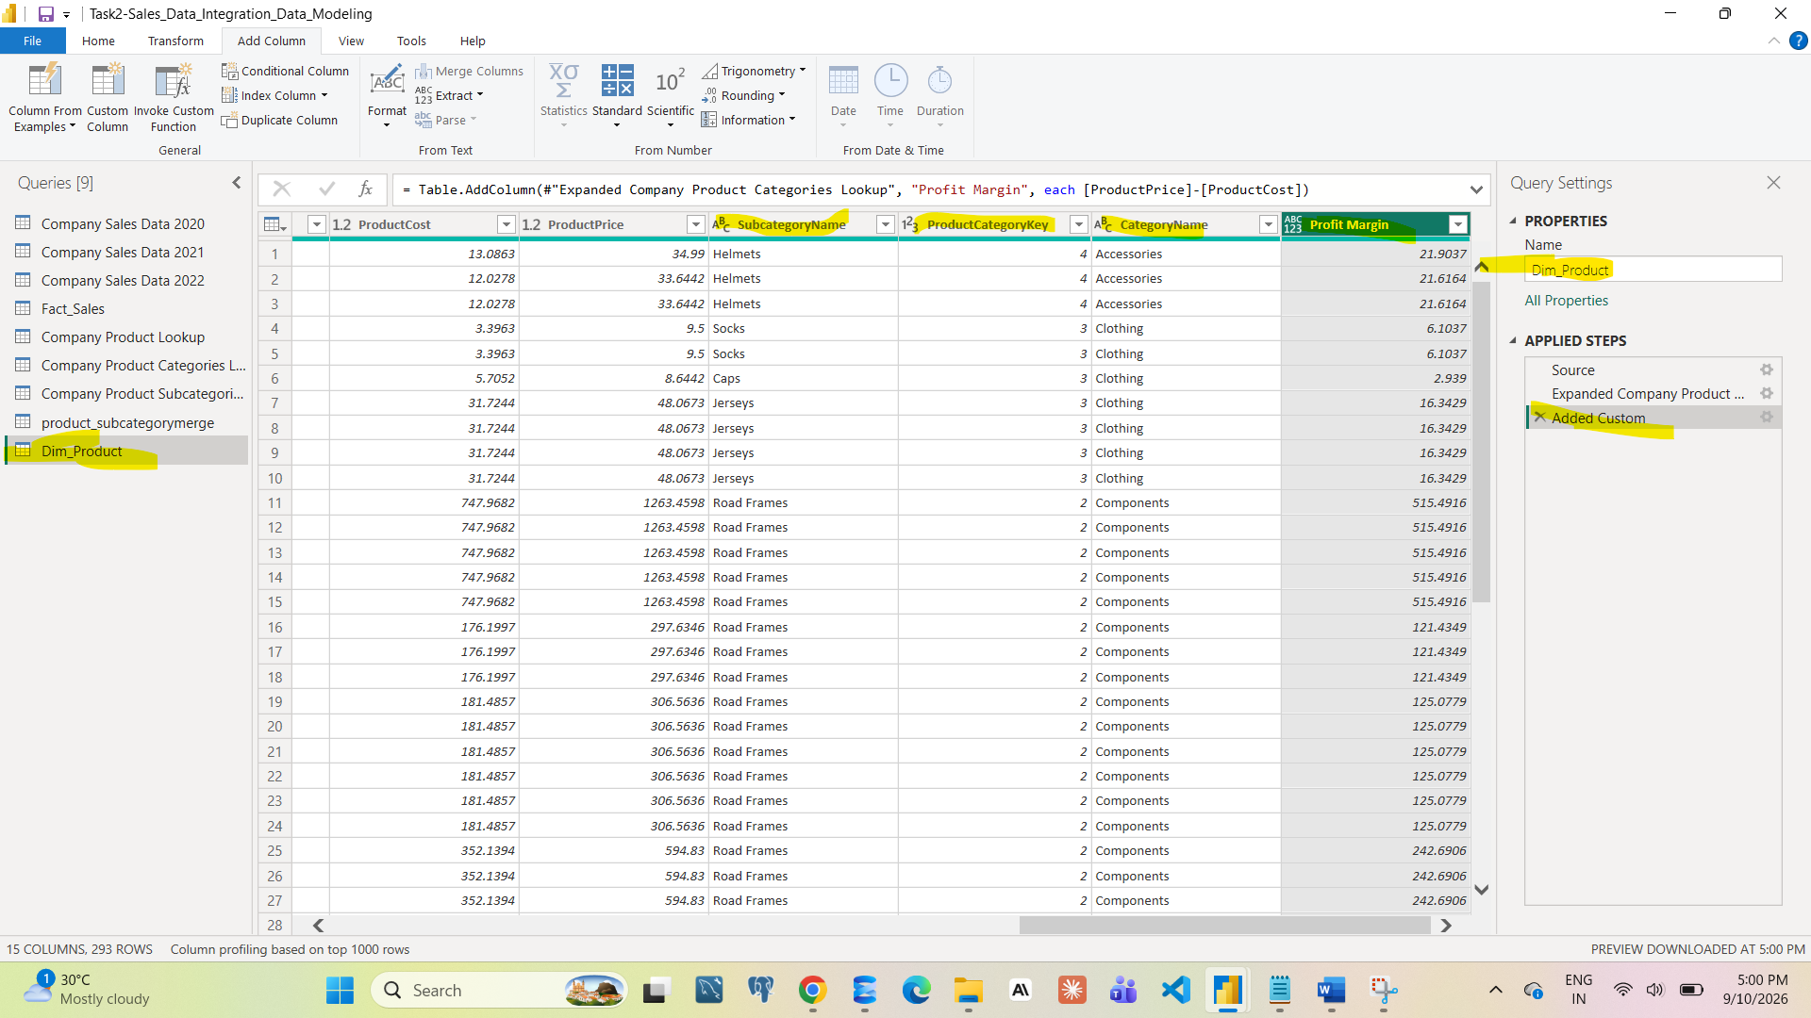
Submission Type : Screenshot of this part is required and saved in Doc/PDF file.
Analytical Questions
Q4. Calculate number of products in each Product Category and identify the category with maximum products.
Q5. Calculate average Profit Margin for each Product Category and identify low or negative margin categories.
Submission Type : Answer of this part is required and saved in Doc/PDF file.
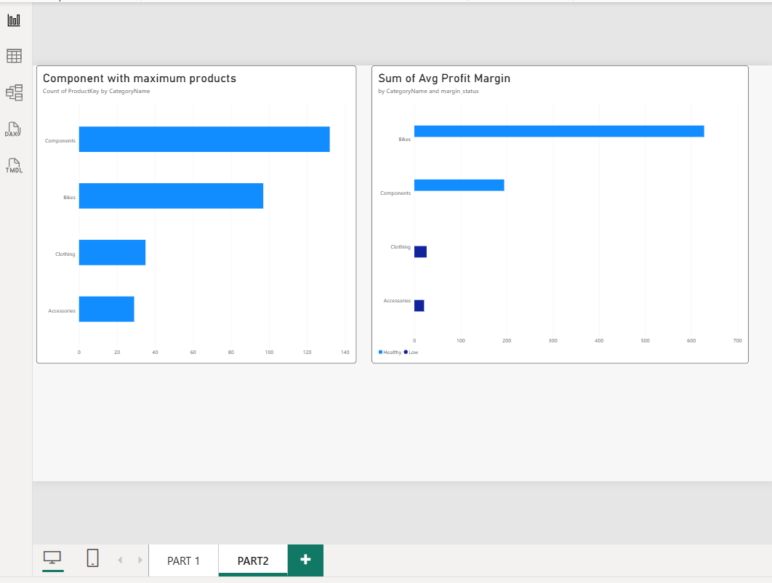

Part 3: Calendar Data Preparation
Tasks
- Convert Date column into proper Date format.
- Create the following columns:
  - Year
Month Number
  - Month Name
  - Week Number
- Rename the final query as Dim_Calendar.
- 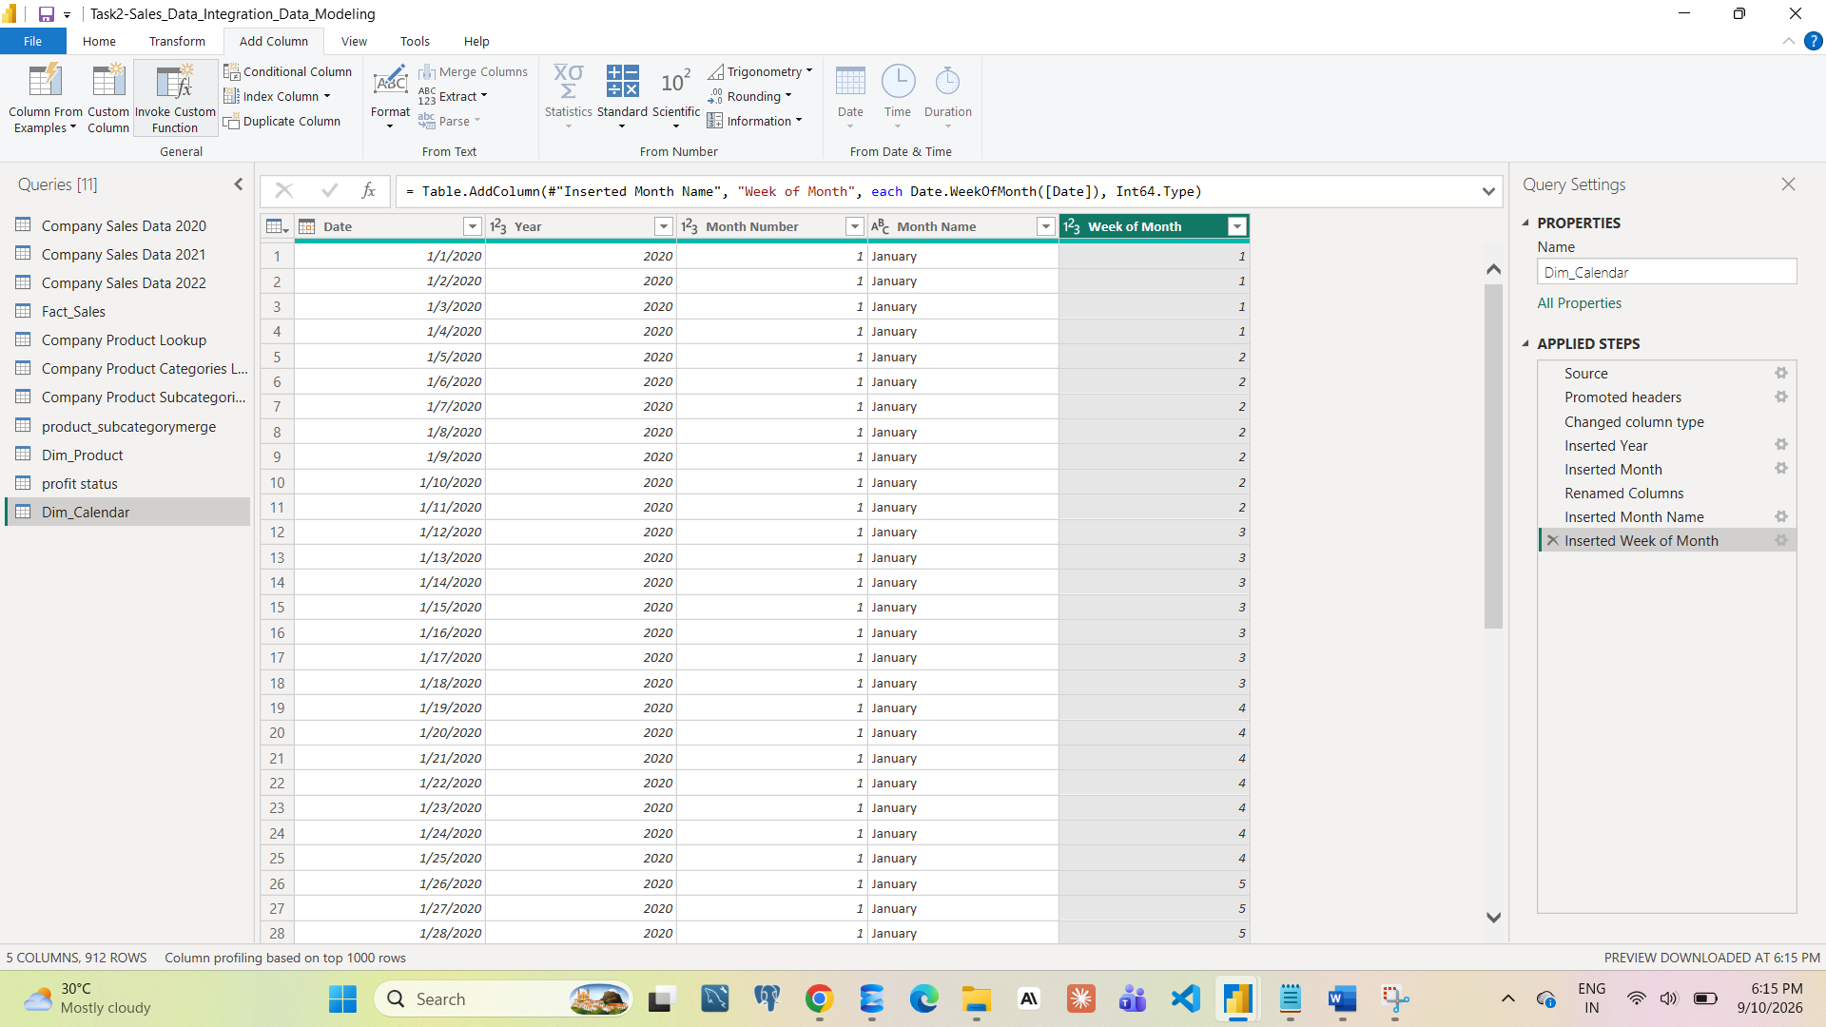
Submission Type : Screenshot of this part is required and saved in Doc/PDF file.
Analytical Questions
Q6. Count how many dates exist in each year and identify if any year has missing dates.
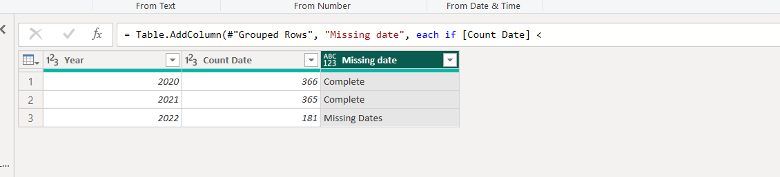

Q7. Identify the maximum week number per year.
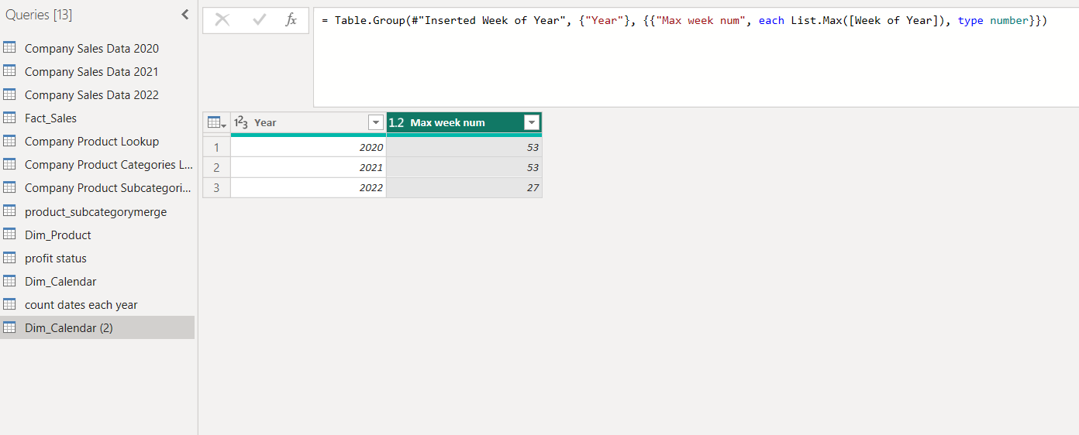
Submission Type : Answer of this part is required and saved in Doc/PDF file.

Part 4: Data Integration Check
Tasks
- Merge Fact_Sales with Dim_Product using ProductKey.
- Merge Fact_Sales with Dim_Calendar using OrderDate.
- Validate:
  - No duplicate records
  - Correct data types after merging.
Submission Type : Screenshot of this part is required and saved in Doc/PDF file.
Analytical Questions
Q8. Calculate total OrderQuantity by Product Category and identify the top-performing category.
Q9. Calculate Year-wise OrderQuantity using Dim_Calendar and compare with Part 1 results.
Submission Type : Answer of this part is required and saved in Doc/PDF file.

Submission Output
You must submit one ZIP folder containing:
- Doc file OR PDF file (Screenshots + Answers in the same document)
- Power BI (.pbix) file

Submission Instructions (Read Carefully)
- Add all screenshots and answers inside one Doc file or one PDF file.
- Place the Doc/PDF file inside a folder.
- Compress the folder into one ZIP folder
- Upload only the ZIP folder
Do NOT upload individual files.
Do NOT upload multiple ZIP folder.

Watch this to learn how to create ZIP file
https://youtu.be/c7x-Q3AQEgw?si=_mS4c7OXADQ7DroE
If you have any doubt, you can directly contact your mentor.

